HOW TO TURN A WIGSTAND  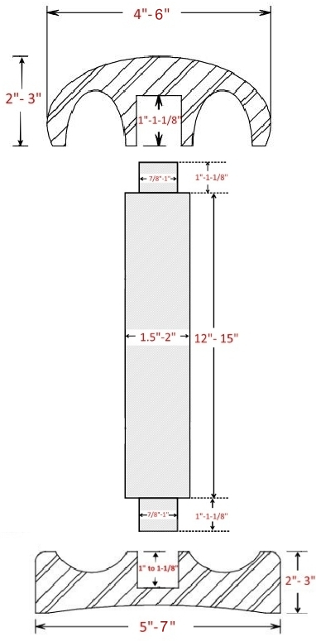 | TOP  1. The diameter can range from 4” to 6” and the thickness from 2” to 3”. Proportions should be pleasing.  2. Mount the piece between centers.  3. Turn the outside surface leaving a tenon.  4. Reverse the piece, mounting it with the tenon using a chuck.  5. Drill a 7/8” to 1” diameter hole, 1” to 1-1/8” deep in the center. (If you prefer you can drill the center hole out after you hollow the inside. This way you can keep your live center on the piece for stability.)  6. Hollow out between the center hole and edge to reduce the weight. Make the rim no thinner than ¼” thick.  7. Sand the interior.  8. Reverse the TOP holding it in spigot jaws in expansion mode.  9. Remove the tenon and the sand the exterior of the top.  BASE  1. The diameter of the BASE should be roughly 20% larger than the TOP to provide stability. Diameter 5” to 7” and the thickness 2” to 3”. This is just a suggestion. Proportions should be pleasing.  2. Mount the piece between centers.  3. Turn the outside surface leaving a tenon.  4. Reverse the piece, mounting it with the tenon.  5. Drill a 7/8” to 1” diameter hole, 1” to 1-1/8” deep in the center. (If you prefer you can drill the center hole out after you hollow the inside. This way you can keep your live center on the piece for stability.)  6. Turn a shallow recess on the top surface. This can be used to hold hair pins, rings earrings, etc. Make the rim no thinner than ¼” thick.  7. Sand the interior.  8. Reverse the BASE holding it in spigot jaws in expansion mode.  9. Remove the tenon and the sand the exterior of the top.  SPINDLE  1. The visible length of the SPINDLE can range from 12” to 15”. The longer the spindle the wider the base for stability.  2. Mount the piece between centers and leave a tenon (on each end) 7/8” to 1” in diameter, 1” to 1-1/8” long, depending on the size of the hole you drilled in the TOP and BASE. You want the tenons to fit snugly in the TOP and BASE  3. Let your creative juices flow while creating the spindle!  4. Sand the SPINDLE.  FINISHING  1. Finish the BASE, SPINDLE, and inside of the TOP with your favorite finish.  2. HOWEVER, preventing the transfer of anything to the wig is critical. Since there is often moisture on the wigs when placed on the stands, having a finish resistant to that moisture is imperative. That takes oil and wax finishes off the table. A water-based polycrylic sealer is recommended. It is more resistant than lacquer, looks nice, and is easy to apply.  ASSEMBLY  1. A waterproof wood glue or epoxy is recommended Since it may be subjected to water or solvents.

